1. Course Scope:

This one-year course (Composition and Themes in American Text) provides instruction in the English Language Arts strands identified by the Nevada Academic Content Standards (NVACS) as reading, writing, speaking and listening, and language. This course is designated as honors level by the accelerated pacing and depth of content. This course requires expository, analytical, and argumentative writing assignments that are based on readings representing a wide variety of prose styles and genres. The course is structured around multicultural themes and perspectives found in literary, non-fiction, and expository texts by American authors to encourage students to think conceptually about the American past, present, and future as well as about the ethnic and cultural diversity of the American experience. Instructional practices incorporate integration of diversity awareness including appreciation of all cultures and their important contributions to society. The appropriate use of technology and digital media are integral parts of this course. This course fulfills one of the English credits required for high school graduation.

II. Course Goals:

- To use complex rhetoric in writing or speaking that includes controlling tone, establishing and maintaining voice, and achieving appropriate emphasis through mature diction and structure. [W.11-12.1, 2, 4, 5; SL.11-12.1, 4, 6; L.11-12.1, 3, 5, 6]

- To combine elements of different genres to produce complex and nuanced writing.
[W.11-12.1-4]

- To explore a variety of American literary, non-fiction, and expository texts of exceptional craft and thought whose range provides opportunities to identify and explain in writing or speaking a writer’s use of rhetorical strategies and techniques.
[RL.11-12.1-7, 9, 10; RI.11-12.1-10; W.11-12.1, 2, 4, 9; SL.11-12.3]

- To understand various stylistic effects achieved by writers’ or speakers’ linguistic and rhetorical choices. [RL.11-12.5; RI.11-12.5, 6; W.11-12.1b, 2d; SL.11-12.3; L.11-12.5]

- To analyze, interpret, and critique a wide variety of primary sources such as documentary materials, works of art, pictorial and graphic materials, and complex text that reflect an author’s historical, cultural, or social perspective.
[RL.11-12.6, 9; RI.11-12.6, 9; W.11-12.7-10; SL.11-12.3]

- To engage in research and inquiry to draw upon collected evidence in support of written analysis, reflection, and discussion, whether writing or speaking.
[W.11-12.7-9; SL.11-12.4-6]

- To develop and demonstrate a range of speaking and listening skills built around sophisticated content that fosters critical listening and informed expression of ideas.
[SL.11-12.1, 3-6]

- To demonstrate control and consistently use the conventions of standard English grammar as well as the ability to choose words appropriate to audience, task, purpose, and discipline to communicate ideas in writing or orally. [W.11-12.4-6; SL.11-12.6]
Revised May 2008, November 2011.

III. Course Overview
There are four quarters in the school year in which we shall study a wide range of literature from various periods in American history/literature, and from various areas in multicultural literature. Most of the literature will encompass excerpts from fictional and non-fictional stories. There will be poetry interpretations, and critical reading, annotations and analysis of characters from plays, short stories, and novels. We shall focus heavily on writing, reading, vocabulary and grammar skills to help students prepare for success in college level courses. A lot of what we shall study will be based on the core standards for English 11 H. We shall also learn skills in analyzing, synthesizing, evaluating and interpreting facts and ideas about literature and the world around us.

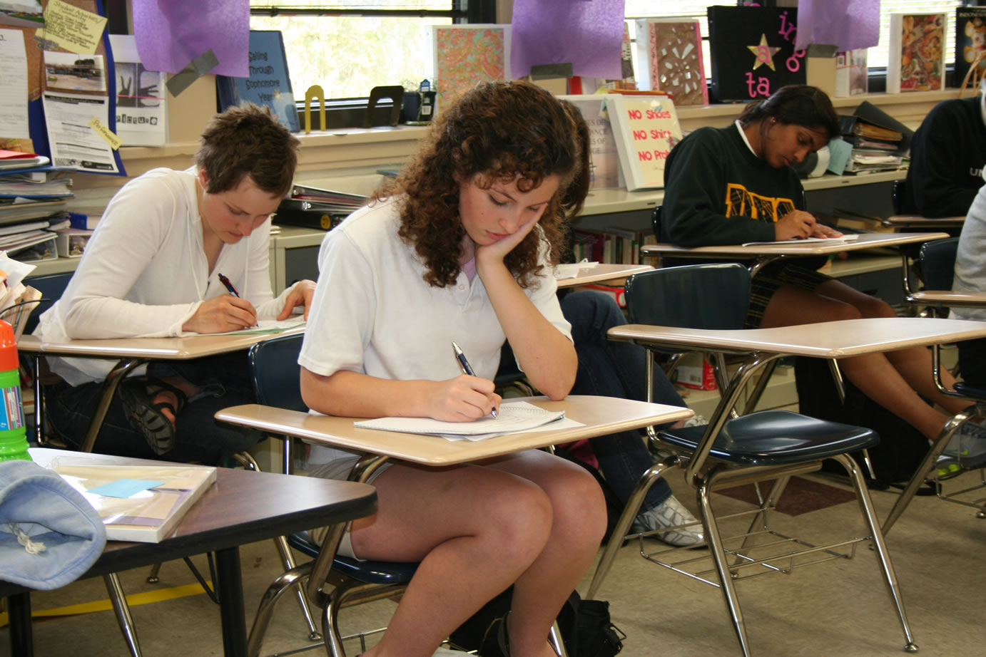
IV. Textbook
Students will be issued CCSD approved textbooks. There will be a grammar textbook and a literature textbook for this class. All other literary and informational texts will be distributed to students as needs be. Most of the materials for learning will be distributed as e-learning materials retrievable from my website at www.adventuresinliterature.weebly.com, or from various URLs as stipulated by the instructor. There will also be some outside reading materials that would be provided by students.

V. Grading & Evaluation
CCSD Regulation 5121 requires teachers to assess student success in mastering the standards presented. Quarterly and semester grades are based on formative and summative measures which evaluate the following English Language Arts content standards.
Description of Learning Activity / Assessments | Possible Points
Reading Literature and Informational Text Assessment - Students read daily and practice critical and close reading by keeping a Reader’s Response Journal or other annotation record. Reading quizzes and tests provide evidence of mastery. | 0 - 250 points  per assessment
Writing Assessment - Students create and publish several short and extended writing projects per quarter such as expository essays, literary analyses, narrative/descriptive essays, argumentative essays, short stories, poetry, rhetorical precis paragraphs, journals, or letters. | 0 - 250 points  per assessment
Speaking and Listening Assessment - Students participate in Socratic discussions with peers or the whole class to practice effective speaking and listening skills. Students will pay special attention to details and qualities to evaluate the perspective, logic, evidence, and use of rhetoric in presentations or discussions. Students use technology to present research or make class presentations. | 0 - 250 points  per assessment
Language Assessment - Students will use proper forms of English - spelling, grammar, usage, and conventions - when speaking or writing. Vocabulary acquisition and proper usage are key aspects of language assessment. Grammar and vocabulary quizzes provide evidence of mastery. | 0 - 250 points  per assessment

Formative assessments are used to measure a student’s progress toward mastery of ELA standards during instruction in order to gather real-time information about a student’s learning needs. Formative assessments will amount to 20% of your grade. Summative assessments are used to measure a student’s mastery of ELA standards post instruction in order to issue a grade. CSN High School uses summative assessments to calculate quarter and semester grades. Summative assessments will amount to 80% of your total grade.
“A” = 90.0 - 100.0% Excellent
“B” = 80.0 - 89.9% Above Average
“C” = 70.0 - 79.9% Average
“D” = 60.0 - 69.9% Below Average
“F” =50.0 - 59.9% Failure

I will update and post student grades to Infinite Campus. I will send home progress notices midway through the first nine weeks or each quarter for students who are earning lower than a “C” average or whose behavior needs improvement. Students who have eight (8) or more absences may lose credit for the course.
The first and second semester grades will be calculated using the following formula:

SEMESTER ONE
Quarter 1 percentile earned is weighted at 45%
Quarter 2 percentile earned is weighed at 45%
Semester 1 examination is weighted at 10%

SEMESTER TWO
Quarter 3 percentile earned is weighted at 45%
Quarter 4 percentile earned is weighted at 45%
Semester 2 examination is weighted at 10%

b. Extra credits
No extra credit may be awarded to any student.

c. Citizenship Grade
Outstanding: Work Habits, Attitude, and Behavior
- Thoroughly completes all assignments including homework by the due dates given. Classroom participation is constructive and elevates the academic discourse of the course. Always on task during class and follows instructions given. No unexcused tardies; attends class consistently. Constantly models exceptional behavior and respect for teacher, peers, and property. Demonstrates a high level of academic integrity. Follows CCSD and CSN expectations of student conduct
Satisfactory: Work Habits, Attitude, and Behavior
- Fewer than three late or missing assignments including homework. Classroom participation is constructive and supports the academic discourse of the course. Rarely off task during class and generally follows instructions. Fewer than three unexcused tardies; attends class regularly. Consistently models acceptable behavior and respect for teacher, peers, and property. Demonstrates academic integrity. Follows CCSD and CSN expectations of student conduct
Needs Improvement: Work Habits, Attitude, and Behavior
- Three or more late or missing assignments including homework. Classroom participation is rare or does not support the academic discourse of the course. Frequently off task during class and ignores some instructions. Three or more unexcused tardies; attends class sporadically. Demonstrates unacceptable or negative behavior and lacks respect for teacher, peers, or property. Demonstrates academic dishonesty. Violates CCSD and CSN expectations of student conduct.
Unsatisfactory: Work Habits, Attitude, and Behavior
- More than five missing assignments including homework. Classroom participation is obsolete or does not support the academic discourse of the course. Consistently off task during class and ignores most instructions. More than five unexcused tardies; attends class sporadically. Demonstrates unacceptable or negative behavior and disrespects teacher, peers, or property. Demonstrates academic dishonesty. Violates CCSD and CSN expectations of student conduct

VI. Homework and Make-Up Procedures:
(a) Students will have homework as often as the teacher deems appropriate. Homework will be posted on the white board in the classroom, handed out if it is a worksheet, or on the teacher's web page. Homework is due at the beginning of the class period or delivered online as may be requested. All handwritten assignments must be in black or blue ink; no pencils please, and all typed assignments must be in (12point Times New Roman, Century Gothic, or Comic Sans fonts-Doubled spaced, using the MLA writing style). Any student found completing an assignment in class would not receive any credit, unless the teacher gives the time to the students to do so. In addition, all work must be legible in order to receive full credit. It is the responsibility of the student to turn in his or her assignment.. It is expected that you do your homework to the best of your abilities. Work turned in late will receive partial credit, up to 30% off the total grade earned for the assignment. No work will be accepted later than one week past the due date.
(b) If a student were absent the day an assignment was given, the student must ask about the assignment or check the teacher's website to find missed assignment, and complete it within three days of return. No additional extension may be granted. The daily objectives and homework assignments will be written on the board in the classroom or the teacher's website. It is the responsibility of the student to copy the missing assignment and homework in his or her homework assignment notebook, as soon as he or she comes to class. If worksheets were used, copies of those will also be retrievable in the teacher’s office or you can get printable copies from the teacher’s website.
(c) Students must remember to write their names, period numbers, dates, and the title of their assignments on their papers before turning them in for grades. If no name on the paper, it will result in partial grade for the assignment. If a student fails to write in blue or black ink, or types his or her work without following the rules for presentation of typed work, he or she will receive an incomplete for the paper, and will be required to redo the assignment.

VII. Rules
1. Readiness
Come to class prepared with the necessary materials and attitude. The necessary attitude is one that is ready and eager to learn new things and come to a greater understanding of yourself and your surroundings in this universe.
2. Respect
Show respect to your fellow students. Absolutely no verbal or physical abuse of any kind will be tolerated in the classroom. Respect ideas, opinions and words of others in the same way you wish to be respected. Respect the teacher's right to teach you and run the classroom in the manner she sees fit. Remember, the fastest way to earn respect is to give it.
3. Responsibility
Be responsible for your actions. If you choose to do no work in class, do not blame anyone but yourself for the grade you receive.

VIII. Classroom Behavioral Expectations:
Students are expected to show appropriate behavior at all time. Students must enter the class with the necessary items required for learning (pens, notebooks, textbooks, etc) and must be in seats PRIOR to the start of class. Students must be in their seats, prepared for class, when the class begins or else he or she will be marked tardy.
Any student who disturbs or disrupts the learning process of another student, teacher instruction, or fails to act respectfully toward teachers, administrators, visitors or peers, will:
- receive a verbal warning
- receive an after school conference with teacher
- written up for improper conduct
- receive a required parent conference
A disturbance is defined as talking, interrupting class or the teacher in any manner, hair combing, applying makeup, out of one's seat, talking without permission, or insubordination of any kind.
At appropriate occurrences, a parental phone call will be made.
¨ Serious disruptions such as fighting, profanity, insubordination and endangerment to peers and or teacher will result in an immediate referral to the Counselor/Principal.
¨ Gum chewing, eating or drinking in class is absolutely prohibited.
¨ Students are not allowed to leave the classroom without permission. It is understood that you are in a college setting; however, you are still in a high school classroom.
¨ Students must abide by all school rules, because they will be enforced in the classroom. (Including dress code)

All students should be prepared to take part in classroom discussions, which will center on materials previously assigned, or topics of discussion for the day.

IX. Absences and Tardies:
Absences and tardies will be handled according to the 2016/2017 CCSD and CSNHS policies.

X. Availability for assistance:
Students are strongly advised to ask me for extra help if the need arises. Appointments can be scheduled for any time before school. To schedule an appointment, the student should simply ask. If a conflict occurs, I will give a twenty-four hour notice, and I expect the same consideration in return. I am here to help you, please feel free to come to me.

Please if you, parents or guardians have any questions or concerns regarding this course expectation and discipline procedures, please contact me at the school. Phone number is 651-5859. I will return your call as soon as possible, but please allow 24 hours. You can also reach me by email: aoo562@interact.ccsd.net or adesuwao@gmail.com. You can also post a blog on my website.

I look forward to an exciting year of academic growth and productivity with you and your parents.

Best regards,
Mrs. Adesuwa Osazuwa

